1)You are provided with a ReactJS application and it can be found on the repository with the link provided below.

Create a Docker file for this React application and also create image and run the image as container and the output of the ReactJS application should be shown on the localhost.

Link to GitHub: <https://github.com/snehalherovired/sample_react_aditya_devops>

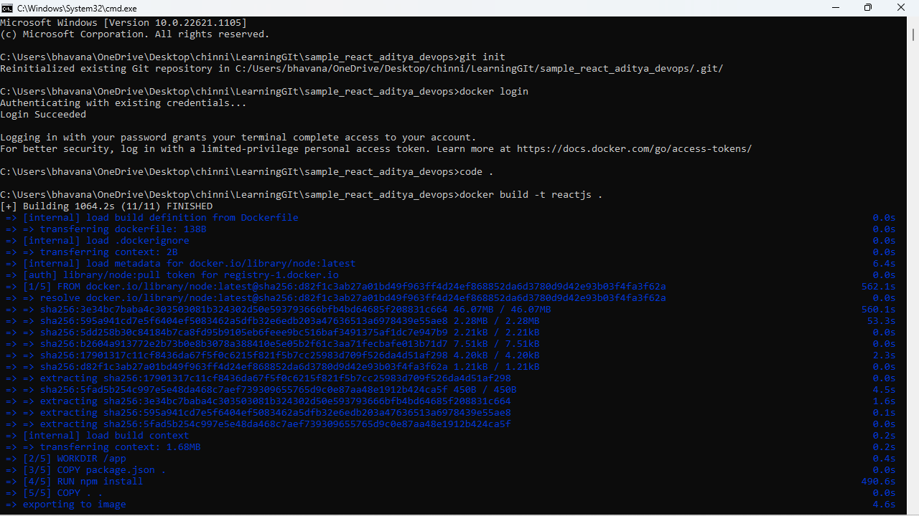

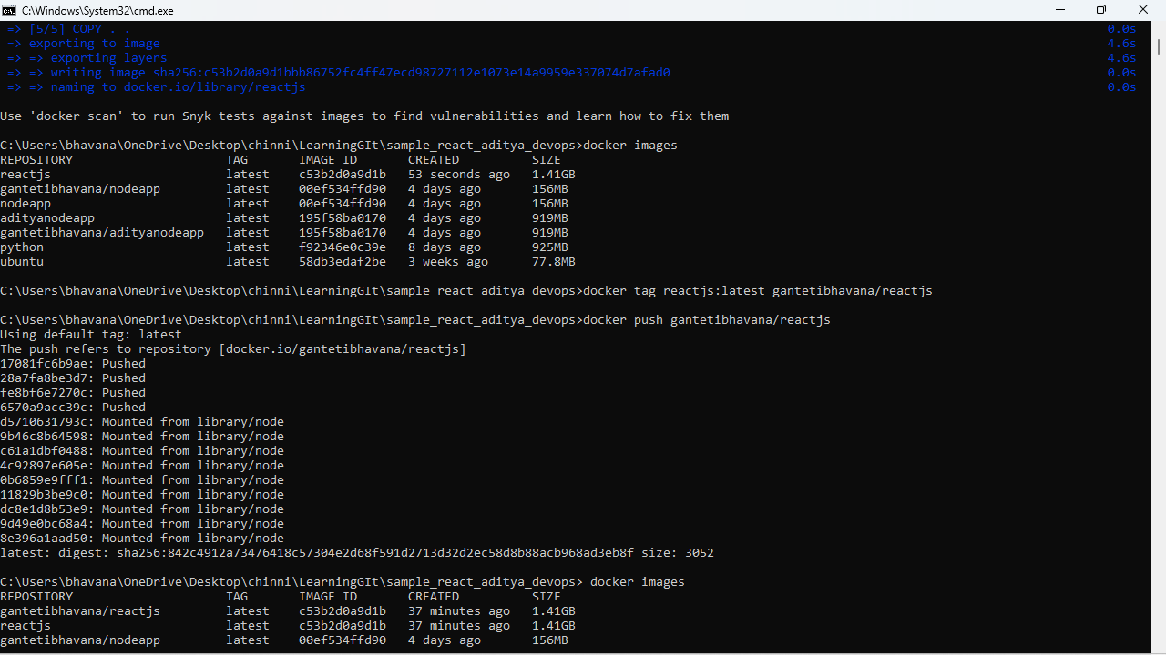

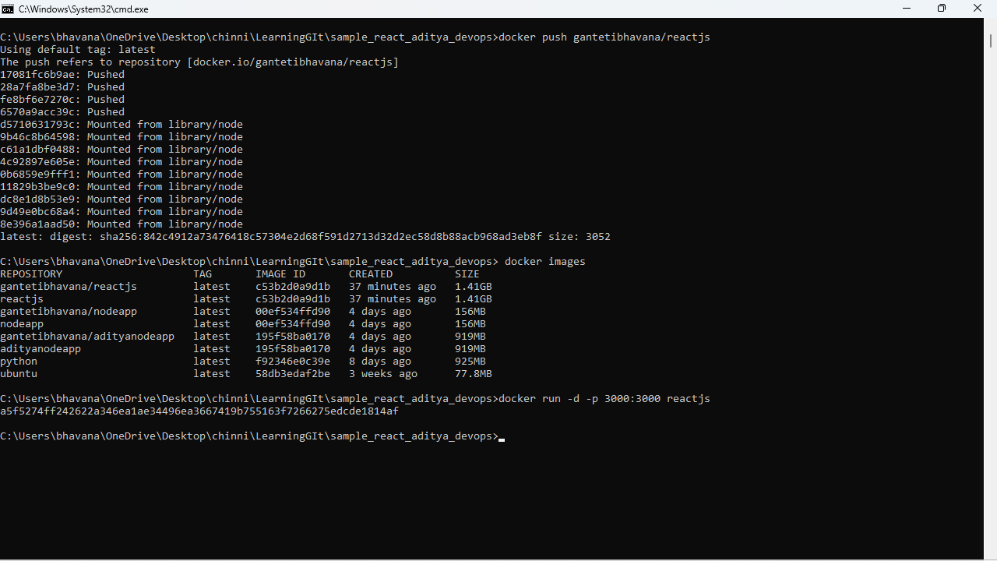

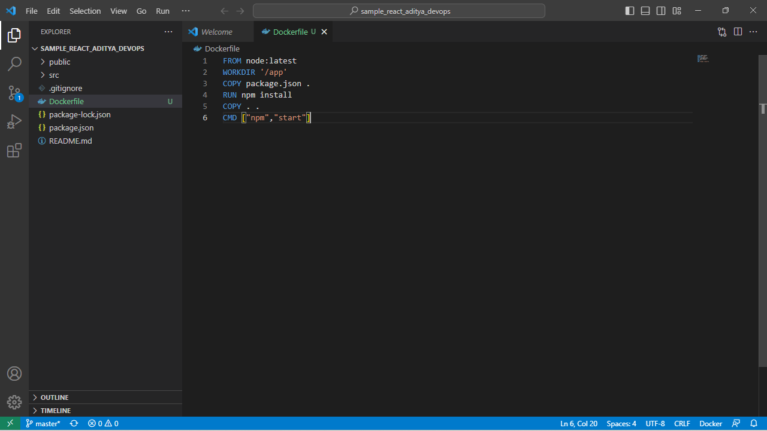

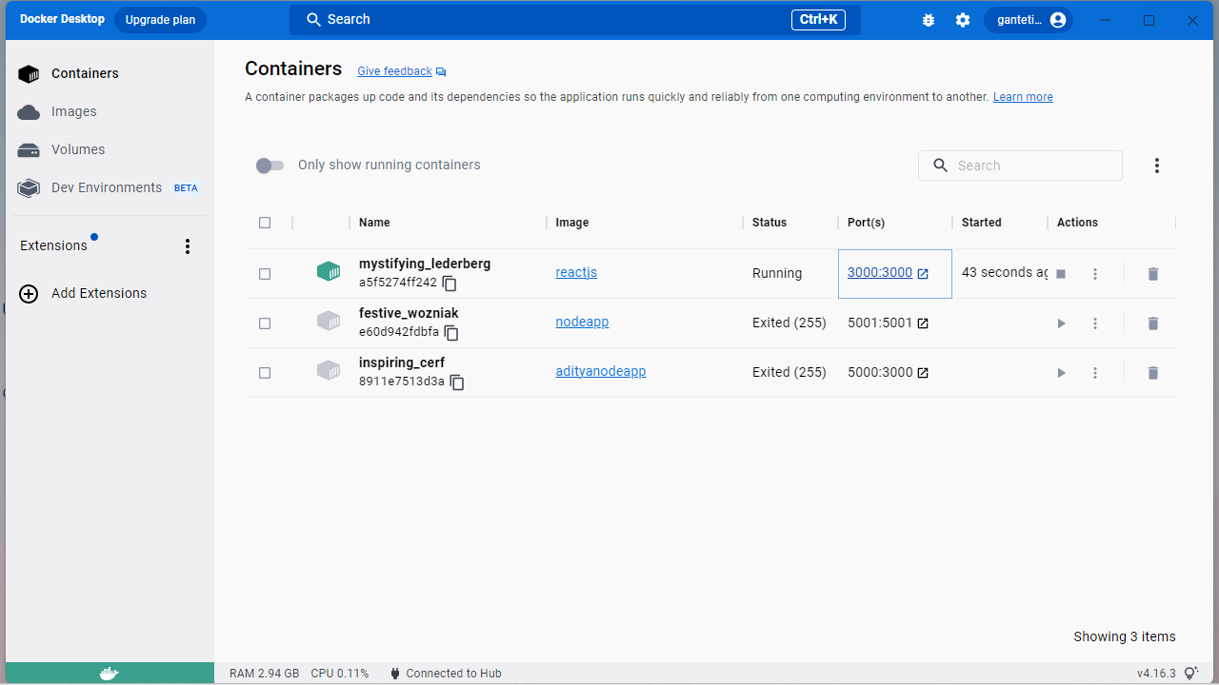

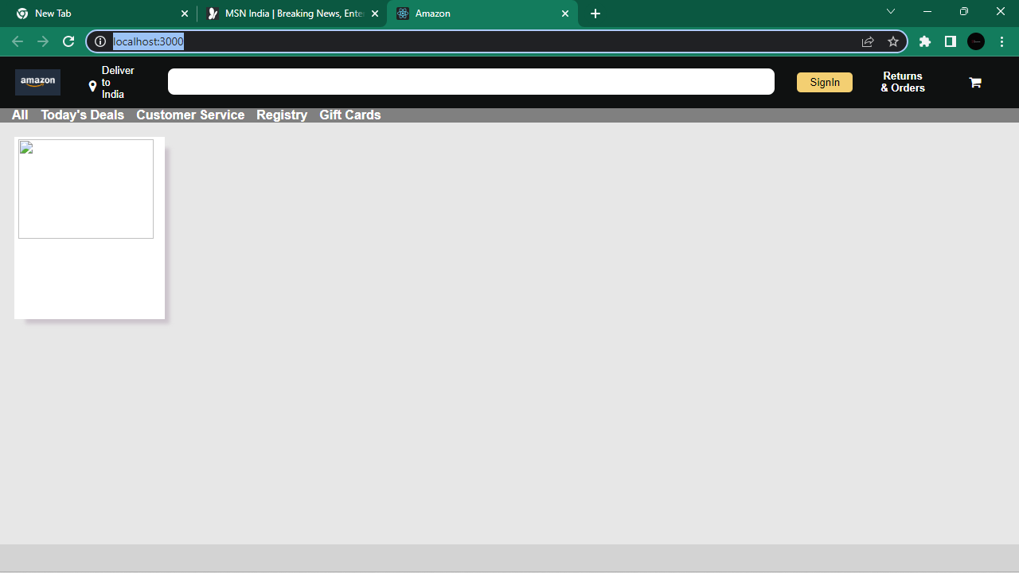

2) Describe the CI-CD pipeline and also describe the role of Jenkins here.

You have to create a manual ci-cd pipeline through bash script and cron jobs for a Nodejs simple application.

For the Node JS application, you can have the same application provided to you on the repository

here : https://github.com/snehal-herovired/LearningGIt.

